**17. Spring MVC Form Validation - Creating Custom Validation Rules**

**Spring MVC Custom Validation**:

Generally, when we need to validate user input, Spring MVC offers standard predefined validators.

However, when we need to validate a more particular type input, we have the possibility of creating our own, custom validation logic.

**Custom Validation Demo**:

Here we create a form and, in this form, we have three fields “Fast Name”, “Last Name”, and “Course Code”. The course code must be start with LUV character. If we enter anything else it displays an error message saying “Course Code must start with LUV”

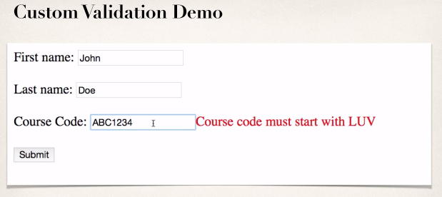

**Custom Validation**:

1. Perform custom validation based on your business rules
2. Our example: Course Code must start with “LUV”
3. Spring MVC calls our custom validation
4. Custom validation returns boolean value for pass/fail (true/false)

**Create a custom Java Annotation … from scratch (Advanced)**:

For custom validation … we will create a Custom Java Annotation **@CourseCode.** This is an advanced Spring MVC work.

@CourseCode(value="LUV", message="must start with LUV")

private String courseCode;

Here, **@CourseCode** is a validation rule that we actually apply to a given field.

**Development Process (Step-by-Step)**:

1. Create custom validation rule
   1. Create **@CourseCode** annotation
   2. Create **CourseCodeConstraintValidator**
2. Add validation rule to Customer class
3. Display error messages on HTML form
4. Update confirmation page

17. Spring MVC Form Validation - Creating Custom Validation Rules